Skyline Custom Reports

The Skyline Targeted Proteomics Environment provides informative visual displays of the raw mass spectrometer data you import into your Skyline documents. It allows you to work with this data, to refine the peptides and transitions you are measuring and to tune integration boundaries. A rich variety of calculated values and statistics may be exported from your Skyline document to a tabular comma separated value (CSV) file perfect for further analysis in tools like Excel and R. The Skyline Results and Document Grids provide access to many of these values and allow you to edit custom annotations and native properties as you work with your data.

The first part of this tutorial will focus on Skyline custom reports. You will learn how they can be designed, shared and used to export raw values and summary statistics from your Skyline documents. Exported reports can be used in the following ways:

* Deeper statistical analysis in tools like Excel or R
* Broader statistical analysis across multiple experiments and/or laboratories
* Enforcing instrument quality control with summary statistics
* Providing an input format for other custom built software tools
* Providing an import format suited to relational data repositories

In developing Skyline we aim to create a vendor-neutral platform for targeted mass spectrometry investigation. Skyline can export similar custom reports for documents populated with the data from Agilent, Bruker, SCIEX, Shimadzu, Thermo-Scientific and Waters instruments. The ability to create consistent reports across instrument platforms greatly facilitates cross-instrument comparisons and large multi-site studies.

Understanding how to create custom reports, tailored to your own experiments, is critical and described in detail in this Skyline custom reports tutorial.

The second part of this tutorial will focus on the Results and Document Grid views in Skyline, which provide real-time access to many of the data fields available in the custom reports. You will learn to customize columns in the Results and Document Grids for immediate access to important values, as you inspect and refine your mass spectrometer output in Skyline. You will also learn to work with custom annotations to provide a controlled vocabulary for further interpretation of and human interaction with your results, which can also be exported in custom reports.

# Getting Started

To start this tutorial, download the following ZIP file:

<https://skyline.gs.washington.edu/tutorials/CustomReports.zip>

Extract the files in it to a folder on your computer, like:

C:\Users\brendanx\Documents

This will create a new folder:

C:\Users\brendanx\Documents\CustomReports

Now open the Study7_example.sky file in this new folder by double-clicking, or by using **Open** on the **File** menu in a running instance of Skyline.

# Data Overview

The dataset in Study7_example.sky is a subset of a study that was performed by the Clinical Proteomics Technology Assessment for Cancer (CPTAC) consortium (T. Addona et al “Multi-site assessment of the precision and reproducibility of multiple reaction monitoring–based measurements of proteins in plasma”, *Nature Biotechnology*, **2009**, 27, 633 - 641). This particular study describes a calibration curve at different concentrations of analyte peptides and a constant spike in level of their corresponding isotope labeled internal standards.

The Skyline file displays data from a subset of CPTAC Study 7.2 data (in the paper referred to as “Study II”) acquired at one CPTAC site. The Skyline file shows data for 10 different peptide sequences monitored by LC-MRM-MS with concentrations for the analyte proteins (see light peptides) ranging from concentrations at 500 fmol to 2.92 fmol (replicates J: 500 fmol; I: 275 fmol; H: 151 fmol; G: 83 fmol; F: 46 fmol; E: 25 fmol; and D: 8.55 fmol – lower concentration points although acquired are not included in this tutorial). Heavy internal standard (IS) peptides are each spiked in at a concentration of 50 fmol.

To get a first impression of what this dataset looks like perform the following steps:

* Click on the ‘HGFLPR’ peptide in the **Targets** view to select it.
* On the **View** menu, choose **Peak Areas**, andclick **Replicate Comparison** (F8).

A new window appears that shows a bar graph of peak area for each replicate. The blue bars represent the heavy labeled version of this peptide (always spiked in at 50 fmol), and the red bars represent the light analyte at varying concentrations (each concentration point was acquired in technical quadruplicate).

Other tutorials describe how you can view and edit documents like this one. For the purposes of this tutorial, however, the Study7_example.sky document has received an initial integration review, fully preparing if for reports to be exported and used in deeper statistical analysis. Before continuing with the rest of the tutorial:

* Close the **Peak Areas** view.

# Creating a Simple Custom Report

To create your first Skyline custom report template, perform the following steps:

* On the **File** menu, choose **Export**, and click **Report**

An **Export Report** form will appear that will probably list at least the Skyline default report templates shown below:

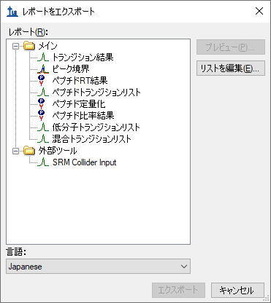

Continue creating a new Skyline custom report template by performing the following steps:

* Click the **Edit list** button.
* In the **Edit Reports** form, click the **Add** button.
* In **Edit Report** form, enter ‘Overview’ in the **Report Name** field.

The form should now look like this:

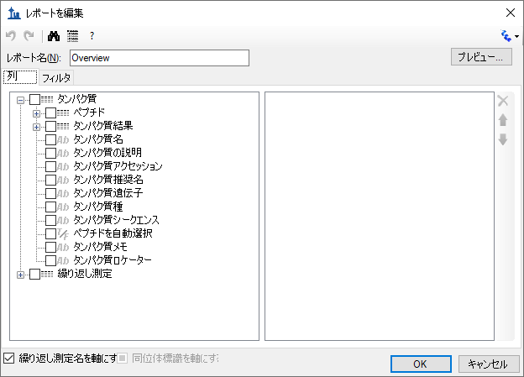

* Expand the field groups **Peptides** and **Replicates** by clicking on the **‘+’** button to see many more fields that can be exported.
* From the expanded **Peptides** group click the checkbox next to the **Peptide Sequence** field.

The form should now look like this:

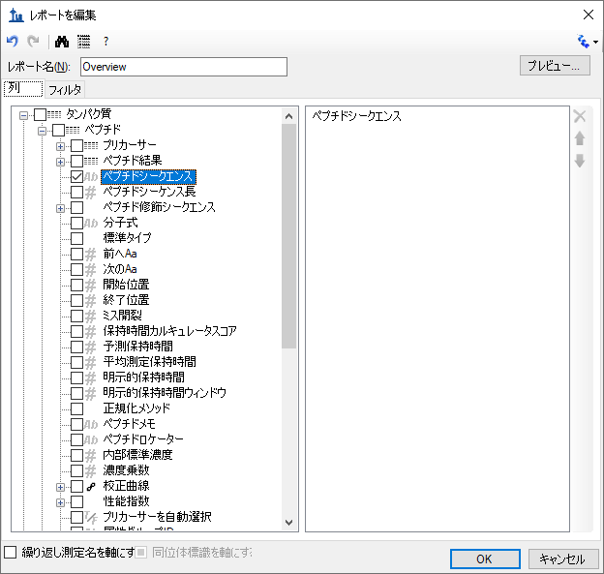

Note that the fields in the **Edit Report** form, shown above, have a distinct hierarchical structure. At the highest level are the *protein specific* fields which are shown at the bottom of the left box (**Protein Name**, **Protein Description**, **Protein Sequence**, **Protein Note**), and the expanded **Replicates**group below these that contains the general field **Replicate Name** among others. Skyline custom reports also provide *peptide specific* fields, contained in the expanded **Peptides** group at the top of the left box, such as **Peptide Sequence** and **Average Measured Retention Time** among others. The peptide specific fields include a **Peptide Results** group, which is not expanded yet. Also unexpanded is the **Precursors** group, which contains *precursor specific* fields, a **Precursors Results** group, and finally a **Transitions** field group. The **Transitions** group, in turn, contains the *transition specific* fields and a corresponding **Transition Results** group, containing the most detailed results values, such as **Retention Time, Fwhm, Start Time, End Time, Area** and **Background**, from which many of the higher level results field values are derived.

In the Edit Report form continue to add fields to your first custom report template by performing the following steps:

* Expand the **Precursors** group (located directly below the expanded **Peptides** group at the very top) by clicking on the ’+’ icon.
* Expand the **Precursor Results** group field now visible in the expanded **Precursor** group.
* Click the checkbox next to the **Isotope Label Type** field from the expanded **Precursors** group. (If necessary, scroll down or resize the form.)
* Repeat this procedure to add the following additional fields from the precursor **Precursor Results** group to the report template column list:
  + **Best Retention Time -** the **RetentionTime** value of the transition with the highest maximum intensity for the particular precursor
  + **Total Area** - the summed **Area** values of all individual transitions for the particular precursor (for more information about these field values, click the “?” button on the tool strip at the top of the **Edit Report** form)
* Check the **Pivot Replicate Name** check box in the lower left corner of the **Edit Report** form.

This should leave the **Edit Report** form looking like:

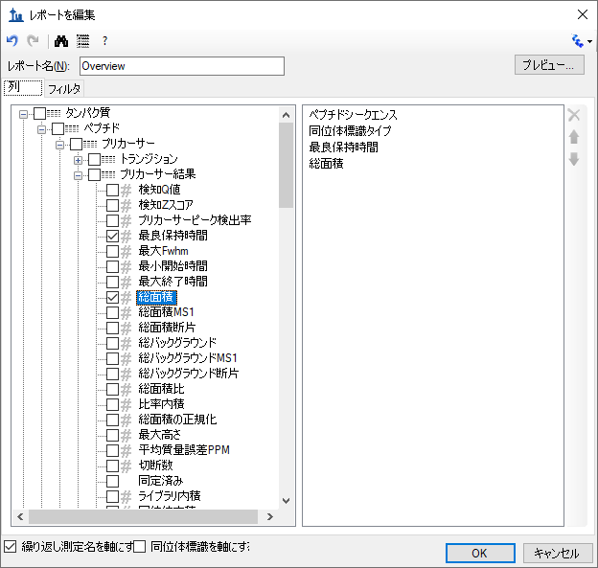

* Click the **Preview** button in the upper right corner of the **Edit Report** form.

The **Preview** form should appear looking like this:

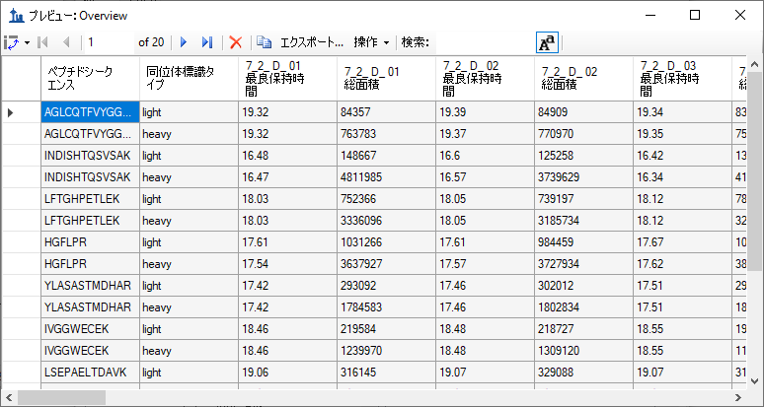

The **Preview** function is quite helpful when designing report templates. At times it may even serve as a quick substitute for exporting a report to a file. The copy button () on the toolbar will copy all of the data including the column headers. You can also select all of the values in the **Preview** form by clicking the upper-left rectangle to the left of the column headers. Pressing Ctrl-C, then copies the full report, excluding the column headers. After copying the data using either method, it can be pasted into another tool, such as Excel.

The report preview displayed in part above, for replicates 7_2_D_01, and 7_2_D_02, shows precursor **Best Retention Time** and **Total Area** for all 10 peptides in both their light and heavy form across all LC-MRM-MS acquisitions/experiments in the columns to the right. By scrolling to the right, you can see columns for all 28 LC-MRM-MS acquisitions. Maximize the **Preview** form by clicking on the square in its upper right corner to see more columns. In this example 7_2_D_01, and 7_2_D_02 are taken from samples at the same light analyte concentration. Therefore, **Total Area** values are expected to be similar. Each letter D through J indicates a different light analyte concentration. Each concentration was acquired in technical quadruplicate, indicated by numbers 01 through 04. The heavy peptide concentrations were held constant at 50 fmol in all samples.

Close the **Preview** form by clicking the ‘x’ in the upper right corner to return to the **Edit Report** form again. To save this report template:

* Click the **OK** button.

You will see the new **Overview** report template appear in the **Report** template list, as shown below:

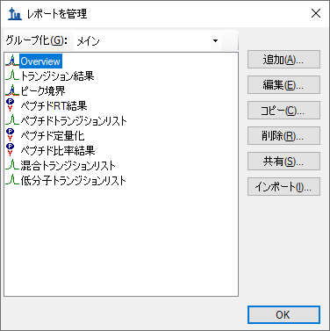

* Click the **OK** button again to return to the **Export Report** form.

The new **Overview** report template is now added to the Skyline report template list. The **Export Report** form should now look like:

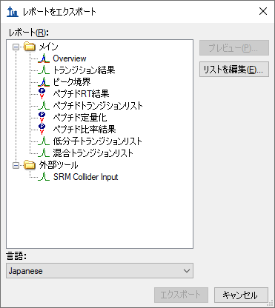

From the **Export Report** form you could now export your new report by selecting ‘Overview’ in the **Report** list and clicking the **Export** button. For now, dismissing the form, in order to start the process from the original Skyline document view.

* Click the **Cancel** button.

# Exporting Report Data to a File

To export the report you created and previewed above to a CSV file, do the following:

* On the **File** menu, choose **Export**, and click **Report**.
* In the **Report** list select ’Overview’.
* Click the **Export** button.
* In the **File name** field of the **Export Report** form enter ‘Overview_Study7_example.csv’.
* Click the **Save** button.

If you switch to a Windows File Explorer window, showing the CustomReports folder you created for this tutorial, you will see the Overview_Study7_example.csv file you just created. Open it now with Excel and confirm that its contents are quite similar to the preview you displayed earlier. Note that the file contains the column header names, which you cannot get by simply copying and pasting from the **Preview** form.

# Sharing Report Templates

Report templates in Skyline are very flexible, easy to manage and modify, and share with collaborators.

There are many reasons you might want to share a custom report template, whether you are participating in a large multi-laboratory study or working with a single collaborator, whether you are providing the proteomics community with your own custom tool that depends on particular fields from Skyline documents or providing supplementary information with a manuscript to allow others to repeat your protocols. The Skyline support for instruments from multiple vendors means your shared report templates can be used to gather data from multiple sites with different instrumentation.

To share the Skyline report template you created in this tutorial, perform the following steps:

* On the **File** menu, choose **Export**, andclick **Report**.
* Click the **Share** button in the **Export Report** form.

Skyline will present the **Manage Reports** form, as shown below:

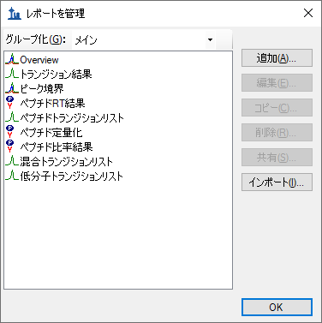

* Click on ‘Overview’ in the list to select it.
* Click the **Share** button.
* In the **File name** field of the **Save As** form enter ‘Overview’.
* Click the **Save** button.

The report template is saved to the file “Overview.skyr” in the CustomReports folder created for this tutorial. You could now share it with your collaborators, with your own analysis tool or as supplementary data for a manuscript.

# Managing Report Templates in Skyline

To gain an understanding of how others would use the custom report template you have shared, you need to first delete it from your system. Then you can add it back using the shared report file “Overview.skyr” that you created in the previous section, as if you had acquired this shared template from someone else.

The **Export Report** form should still be open after the steps performed in the previous section. To delete the ‘Overview’ report template from your Skyline settings, do the following:

* Click the **Edit List** button.
* Select the ‘Overview’ item in the list of the **Manage Reports** form.

The **Manage Reports** form should now look like this:



To remove the ‘Overview’ item from the list, do the following:

* Click the **Remove** button.
* Click the OK button.

The **Export Report** form should now look like this:



Just as when you first brought it up in this tutorial.

To demonstrate how your collaborators would import a new report template into Skyline follow the steps below:

* Click the **Edit List** button to bring up the **Manage Reports** form.
* Click the **Import** button
* Select the ‘Overview.skyr’ file you created earlier in the **Open** form (which should still be showing the contents of the ‘CustomReports’ folder for this tutorial).
* Click the **Open** button.
* Click the **OK** button on the **Manage Reports** form.

These actions should add an ‘Overview’ item back to the **Report** list in the **Export Report** form. To verify that this is indeed the report you saved, perform the following steps:

* Select the ‘Overview’ item in the **Report** list.
* Click the **Preview** button.

Skyline will present a **Preview** form containing the same values you saw earlier in this tutorial.

# Modifying Existing Report Templates

You can, of course, create much more data rich reports than the simple ‘Overview’ report. You can do this by creating another new report template, by editing your existing ‘Overview’ report, or, as shown below, by making a copy of the ‘Overview’ report and editing the copy. To create a new, more complex report from a copy of the ‘Overview’ report template, perform the following steps:

* Click on **Edit List** button in the **Export Report** form.
* Select the ‘Overview’ item in the **Report** list.
* Click the **Copy** button and click **Open Report Editor** on the menu that appears.

Skyline will present the **Edit Report** form with the fields from the ‘Overview’ report template already added, as shown below:

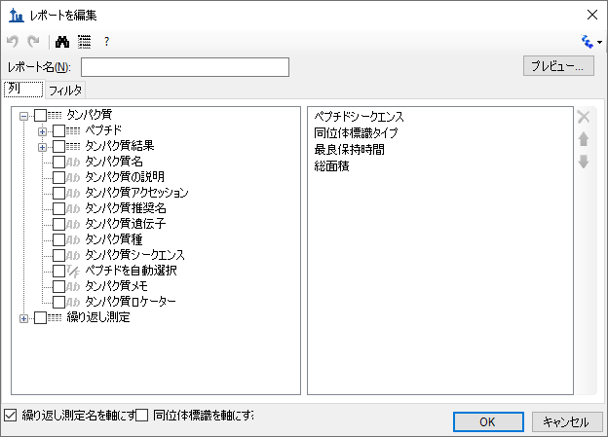

The report name for this new report template has not yet been assigned. To assign it now:

* In the **Report Name** field, enter ’Study 7’.

Continue to add more fields as described below by clicking the checkbox next to each field to add it to the column list for your report template, on the right side of the **Edit Report** form:

* Expand the field groups **Peptides** and **Replicates** by clicking the **‘+’** icons to their left.
* From the expanded **Replicates** group, add the following fields:
  + **File Name** – the name of the file from which the data was imported
  + **Sample Name** – the sample name, if the data was imported from a multi-sample WIFF file, or the file name again, if not
  + **Replicate Name** – the replicate name assigned to the data during import
* From the top level add **Protein Name**.
* From the expanded **Peptide** group, add the **Average Measured Retention Time** field – the average retention time over all replicates.
* Expand the **Peptide Results** group in the expanded **Peptide** group.
* From the expanded **Peptide Results** group, add the following fields:
  + **Peptide Retention Time** – peptide RT for each replicate run
  + **Ratio To Standard** – area ratio of light to heavy
* Expandthe **Precursors** group.
* From the expanded **Precursors** group, add the following fields:
  + **Charge** (displayed in the column list as **PrecursorCharge**)
  + **Mz** (displayed in the column list as **PrecursorMz**)
* Expandthe **Transitions** group.
* From the expanded **Transitions** group, add the following fields:
  + **Product Charge**
  + **Product Mz**
  + **Fragment Ion** – the fragment ion name (e.g. y8, y10, b7, etc.)
* Expandthe **Precursor Results** group in the **Precursors** group.
* From the expanded precursor **Precursor Results** group, add the following fields:
  + **Max Fhwm** - the maximum full width at half max (FWHM) of the transitions for the particular precursor
  + **Min Start Time** - elution time start at the baseline of a peak, which will be the same for all transitions (Q1/Q3) from the same precursor
  + **Max End Time** - elution time start at the baseline of a peak, which will be the same for all transitions (Q1/Q3) from the same precursor
* Expandthe **Transition Results** group in the **Transitions** group.
* From the expanded **Transition Results** group, add the following fields:
  + **Retention Time** – retention time at the maximum intensity for a transition peak
  + **Fwhm** – full width at half max for the transition peak
  + **Start Time** – retention time at the starting transition peak integration boundary
  + **End Time** – retention time at the ending transition peak integration boundary
  + **Area** – area under the curve (AUC), minus background, for the transition peak
  + **Height** – maximum intensity, minus background, for the transition peak
  + **User Set Peak** - indicates whether the peak is unchanged from when Skyline first extracted chromatograms (FALSE) or changed by the user (TRUE). Other values are possible for peaks that may have been change by importing a peak boundaries file, or reintegrating with a trained model (both beyond the scope of this tutorial).
* Also, uncheck the **Pivot Replicate Name** checkbox, at the bottom of the form.

The report template should now contain a lot more detail than the original ‘Overview’ report template, and the **Edit Report** form should look like this:

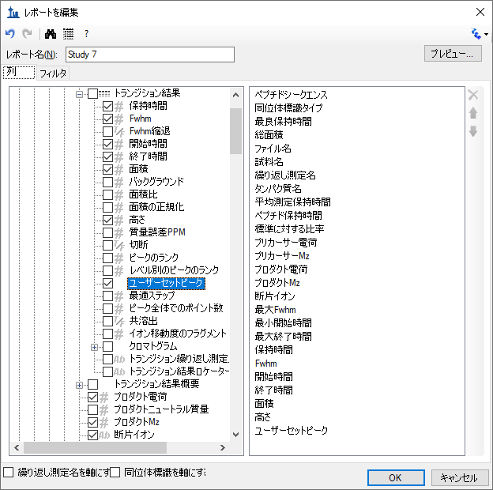

To reorder some fields in this new report template, do the following:

* Select **Protein Name** in the column list on the right.
* Click the up arrow on the far right until the **Protein Name** field is at the top of the list.

You can achieve whatever ordering suits you best, in this way, using the up and down arrow buttons on the far right, and you can remove fields you may have added by mistake with the red ‘X’ button above the arrow buttons, or by unchecking them in the list to the left. This tutorial, however, will continue without making any further changes to the column list.

To preview the values for the current document in the report template you have created, do the following:

* Click on the **Preview** button.
* When you have reviewed the data, close the **Preview** form.

With data like this, where each peptide has both a light analyte and a matching heavy isotope labeled internal standard, it may be more convenient to work with the data for these paired precursors all in a single row to allow you to compare matching transition values more easily.

To make this change to the ‘Study 7’ report template, do the following:

* Checkthe **Pivot Isotope Label** check box.
* Click on the **Preview** button again to see how the report preview has changed.

All of the values for matching light and heavy transitions have been added to the same row. New columns have been added to achieve this, and columns specific to an isotope label type have been given the prefixes ‘light’ and ‘heavy’.

The **Preview** form is shown below, scrolled to show both ‘light’ and ‘heavy’ column names:

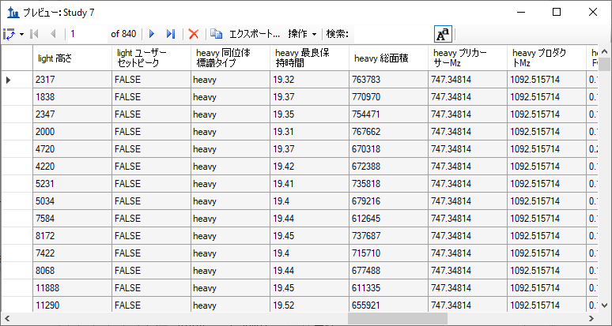

You might notice that the column ‘heavy Isotope Label Type’ shows ‘heavy’ on every row, and that there is also a column ‘light Isotope Label Type’ which shows ‘light’ on every column. When you are pivoting on a column, it does not add much to include it in your column list. Close the **Preview** form, and do the following to remove the ‘Isotope Label Type’ field from this report:

* Select ‘Isotope Label Type’ in the column list on the right.
* Click the red ‘**X**’ button on the far right edge of the column list.

You can click the **Preview** button again to verify that both the ‘light Isotope Label Type’ and the ‘heavy Isotope Label Type’ columns have been removed. The next step in this tutorial, however, is to save your work by doing the following:

* Click the **OK** button in the **Edit Report** form.
* Click the **OK** button in the **Edit Reports** form.

This will return you to the **Export Report** form, which should now look like this:

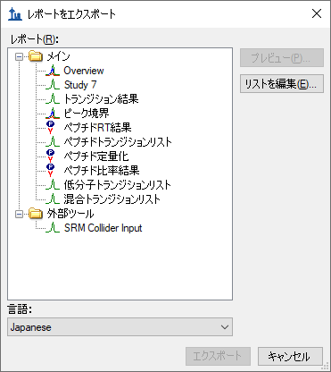

From here, you could now continue to export the new ‘Study 7’ report to a CSV file by selecting it and clicking the **Export** button, or click **Share** button to create file for sharing this new report. For this tutorial, however:

* Click the **Cancel** button to return to the ‘Study7_example’ document.

# Quality Control Summary Reports

So far you have created reports based on the values Skyline offers for each imported replicate of the peptides and transitions specified in a document. Skyline also provides report fields with summary statistics across all imported replicates. These summary fields are particularly suited to quality control by ensuring that replicate QC runs show good reproducibility and coefficients of variation (CV). Skyline report templates can be designed with mean values and CV over all replicates for key parameters, such as peak area, FWHM and retention time.

This tutorial provides a summary report template that you will import into Skyline, but it also describes how to design such a summary report template in the **Edit Report** form.

To get started, first open a new document by doing the following:

* On the **File** menu, click **Open**.
* Navigate to the ‘CustomReports’ folder you created for this tutorial. (if necessary)
* Select the ‘Study9S.sky’ file.
* Click the **Open** button.

This file contains data acquired by two CPTAC sites over 10 LC-MRM-MS runs, injecting 22 analyte peptides at a constant concentration of 50 fmol over all 5 runs. Such a dataset could potentially be used to assess reproducibility of replicate injections. In this part of the tutorial you will begin working with Live Reports, using the report to navigate around the document. To do this you will use the **Document Grid** functionality instead of **Export Report**.

To view the data for key quality control metrics follow the steps below:

* On the **View** menu, choose **Document Grid**.
* At the top of the **Document Grid** form, click the **Reports** button. A dropdown list will appear.
* Choose **Manage Reports** from the dropdown list.
* Click the import button in the **Manage Reports** form.
* Select the Summary_stats.skyr file from the ‘CustomReports’ folder in the **Open** form.
* Click the **Open** button.

A new report named ‘Summary Statistics’ should have been added to the list of reports, and the **Manage Reports** form should now look like this:

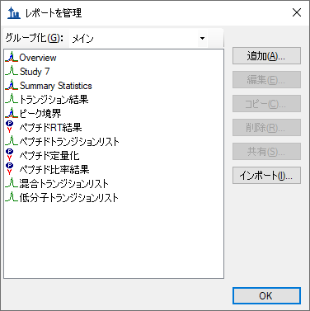

* Click **OK** to dismiss the **Manage Reports** form.
* On the **Document Grid** form, click the **Reports** button and choose ***Summary Statistics***.

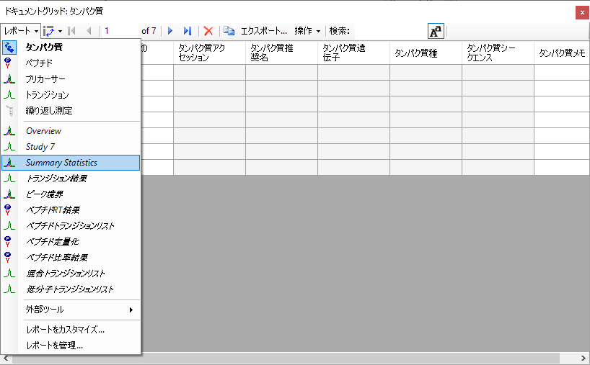

After you choose ***Summary Statistics***, the **Document Grid** should look like the following:

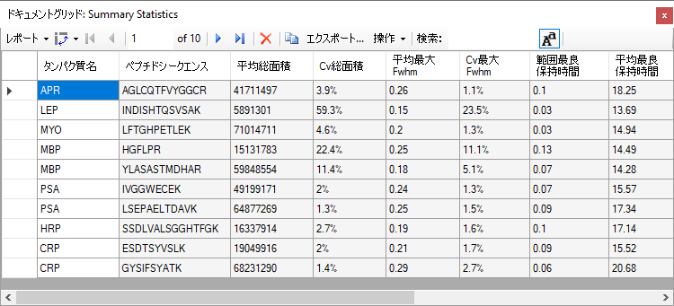

This report shows that the data in Study9pilot.sky, taken from 5 replicate injections of the same sample, produce peptide CV values for **FWHM** mostly below 5% and **Total Area** in most cases under 10% as indicated for the corresponding columns with red boxes. In addition, the column called **Range Best Retention Time** (red box) lists the RT drift in minutes for any specific peptide over the 5 replicate injections. In this case there is only minimal RT drift (< 0.15 min, < 10 sec).

These summary reports can be used to flag quality control issues early, before they impact data acquired on important samples. In this particular dataset, HPLC and MS seem to behave acceptably. In one case, however, for the peptide INDISHTQSVSAK (from protein LEP), the CV value for **Total Area** is 59.2% and for **FWHM** is 23.5% (circled in red), significantly differing from the CV values of all the other peptides.

You can add a filter to this report so that only rows matching specific criteria are shown by doing the following:

* On the **Document Grid** form, click the **Reports** button and choose **Edit Report**.
* In order to find the **Cv Total Area** column in the tree view on the left, double-click on that column name in the list on the right.

The **Customize Report** form should look like this:

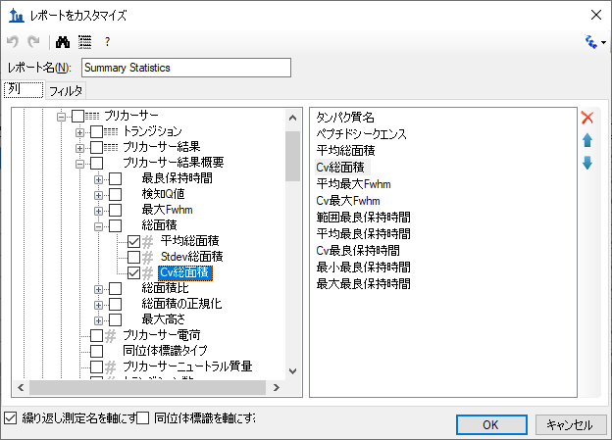

To define a new filter on this report:

* Click the **Filter** tab. The **Cv Total Area** column will still be selected in the tree view on the left.
* Click the **Add >>** button to add that column to the list of filters.
* Set the **Operation** to **Is Greater Than**
* In the **Value** column, enter ‘0.2’**.**

The **Customize Report** form should look like this:

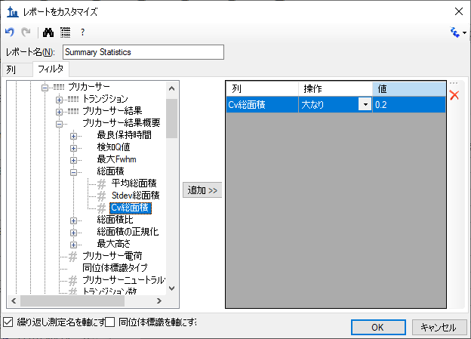

Note that even though the **Cv Total Area** column is displayed as a percentage in the **Document Grid**, on the filter tab, the number “20%” is represented as “0.2”.

* Click the **OK** button on the **Customize Report** form to see the rows matching this filter.

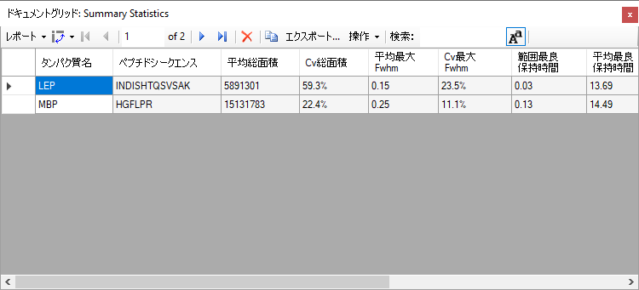

To inspect the INDISHTQSVSAK peptide more closely, do the following:

* Close the **Document Grid** by clicking the red X in the upper right corner.
* Select the peptide ‘INDISHTQSVSAK’ in the peptide tree view.
* On the **View** menu, choose **Peak Areas**, and click **Replicate Comparison** (F7).

The **Peak Areas** view, showing the total peak area and the contribution of each transition for all 5 replicates, helps clarify the problem that was indicated in the CV values of the summary report preview. For comparison, select several of the other peptides. The **Peak Areas** view will show much better peak area reproducibility, as indicated by their much lower **Cv Total Area** values in the summary report preview, where the majority of the peptides had CV values < 10%.

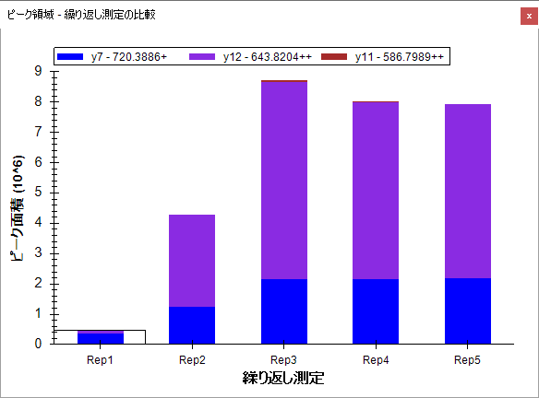

Skyline summary reports can be used with quality control data to flag issues early, while Skyline itself provides powerful visual displays to help get to the root of the problem quickly.

# Results Grid View

In some cases, you may want to see some of the values presented in reports while you are editing the data, for immediate access to raw values displayed in the Skyline charts. The Skyline **Results Grid** view provides real-time access to many of the data fields available in the custom reports. In this sections of this tutorial, you will learn to use the **Results Grid** to gain immediate access to important values and to annotate your data to capture important human insights, as you inspect and refine your mass spectrometer output in Skyline.

To get started using the **Results Grid** view, do the following:

* On the **View** menu, choose **Other Grids**, and click **Results Grid** (Alt-F2).

Skyline should now look something like this:

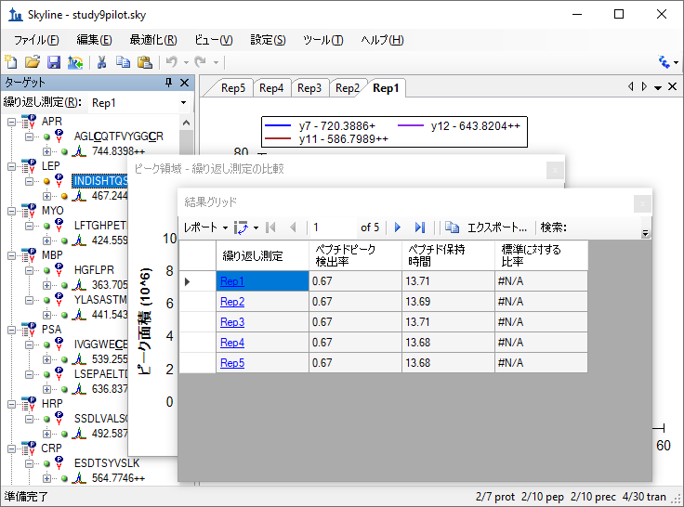

Now rearrange the windows for better viewing, by doing the following:

* Click the **Results Grid** caption and drag it to the bottom edge of the main window to dock it.
* Click the **Peak Areas** caption and drag it to the right edge of the main window to dock it.
* Click and drag the splitters between the various window panes to adjust the space allocation.
* On the **View** menu, choose **Auto-Zoom**, and click **Best Peak** (F11), if it is not already selected.
* In the **Targets** view, select the precursor ‘467.2440+++’ below the currently selected peptide.

This should leave Skyline looking something like:

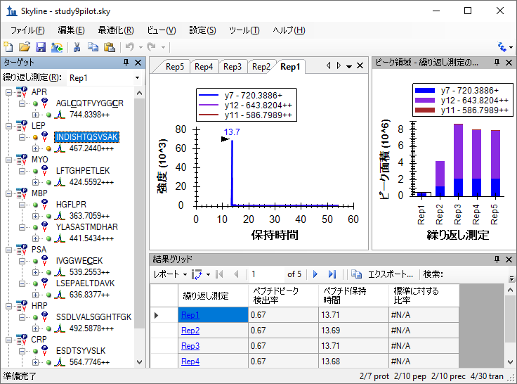

Skyline keeps its charts and the **Results Grid** in synch as you navigate the data. If you click on one of the other rows in the **Results Grid**, Skyline changes the active chromatogram replicate tab. It also changes which bar in the **Peak Areas** graph has the selection rectangle around it, as well as the selection in the **Replicates** list at the top of the **Targets** view.

* Now click on a different bar in the **Peak Areas** plot, or change the selection in the **Replicates** list.

The other views will update, including the selected row in the **Results Grid**.

The first column to the right of the **Replicate** column in the **Results Grid** is the **Precursor Replicate Note**. This column allows you to associate a free text note with the **PrecursorResults** field group for the selected precursor and replicate.

* Type ‘Low signal’ in the first row with replicate name ‘Rep1’ for the currently selected precursor.

The **Results Grid** should now look like this:

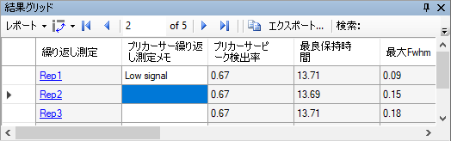

All of the other columns in the current **Results Grid** display are calculated by Skyline and cannot be edited, but you can change which columns get displayed and in what order. Several of the columns are scrolled out of view in the image above. To reduce the number of precursor results columns being displayed, do the following:

* Click the **Reports** button at the top of the **Results Grid**, and choose **Edit Report**.
* On the **Customize Report** form, for each of the columns **Min Start Time**, **Max End Time**, and **Library Dot Product**, click on the column name in the list box, and then click on the X button to the right of the list box.
* Click the **OK** button.

You can now review the results for other precursors by doing the following:

* In the **Targets** view, click on a precursor element.
* Use the arrow keys to change the **Targets** view selection to other precursor elements.

Finally, expand a precursor and review its transitions. You could apply the same technique to customize the columns being displayed for transitions. Instead, continue now to the final section in this tutorial to learn how to add a custom annotation that you can control with the **Results Grid**, and later export in a Skyline report.

# Custom Annotations

Skyline supports three types of custom annotations:

1. Free text (similar to the **Note** which is available by default on all types)
2. Number
3. True/False
4. Value list

The last two types can be used to collect information in a controlled vocabulary, as you process your data, which can later be exported in a Skyline report and used as input for programmatic statistical analysis.

To define a simple new True/False annotation, perform the following steps:

* On the **Settings** menu, click **Document Settings**.
* Click the **Edit List** button on the **Annotations** tab of the **Document Settings** form.
* Click the **Add** button on the **Define Annotations** form.
* In the **Name** field on the **Define Annotation** form, enter ‘Tailing’.
* In the **Type** field, select ‘True/False’.
* In the **Applies To** list, check the **Precursor Results** checkbox.

The **Define Annotation** from should now look like this:

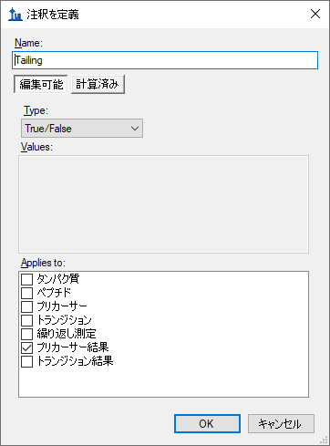

Now save the annotation and add it to your document by doing the following:

* Click the **OK** button on the **Define Annotation** form.
* Click the **OK** button on the **Define Annotations** form.
* Check the checkbox for the new ‘Tailing’ annotation.

The **Document Settings** form should now look like this:

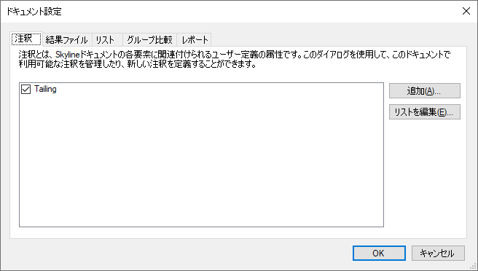

* Click the **OK** button.
* In the **Targets** view, select the precursor element ‘564.7746++’ for the peptide ‘ESDTSYVSLK’.

The new Tailing column will not appear in the custom view in the **Results Grid**, but you can add it:

* Click the **Reports** dropdown at the top of the **Results Grid**, and choose **Edit Report**.
* In the list view on the right, click on the third column down (“**Precursor Peak Found Ratio**”). New columns will be added above this element.
* Click the checkbox next to **Tailing** at the bottom of the tree view on the left.

The **Customize Report** form should now look like the following:

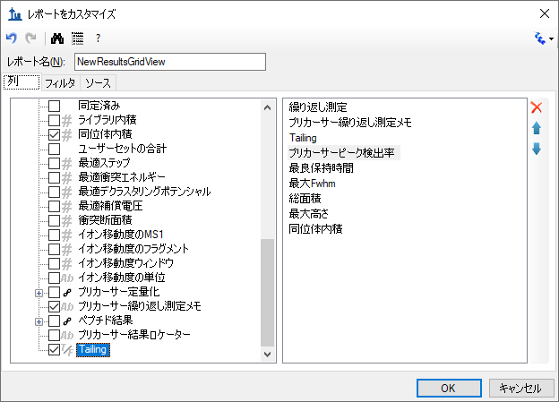

* Click the **OK** button.

You should see the new **Tailing** column added to the **Results Grid** between **Precursor Replicate Note** and **Precursor Peak Found Ratio**

The Skyline window should now look something like this:

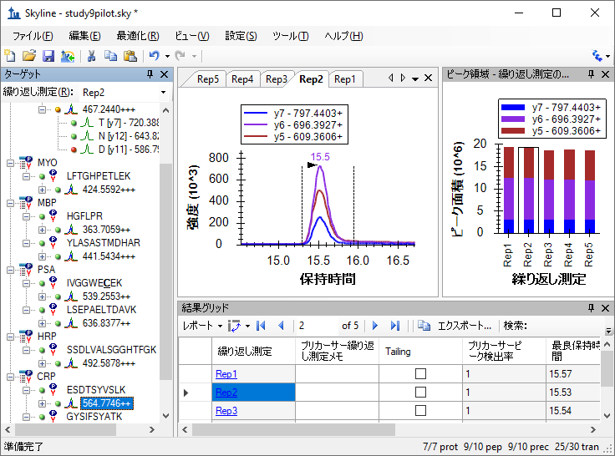

The peaks in this document do not have a lot of issues, but this one does have some peak tailing. Check the checkbox in the new **Tailing** column for the ‘Rep1’ row. Change selection to each of the other 5 rows. Decide whether you think the tailing is worth noting and check the checkbox, if you think it is. Change the selected item in the precursor tree and then return to the ‘564.7746++’ precursor to verify that your changes were recorded.

You can now export the new **Tailing** annotation in a Skyline custom report. It will appear in the **Precursor Results** field group.

# Conclusion

This tutorial has introduced you to the flexible custom reports Skyline offers for accessing the rich set of values associated with your Skyline targeted mass spectrometry documents. These reports offer a smooth path from data analysis within Skyline to more complex statistical analysis with Excel or custom programs coded in R, Matlab, Java or C++. You have learned about summary statistics available through these report templates, which can provide quick indicators of data quality. You can share your custom report templates with collaborators or as supplementary material in your publications, helping others to repeat your analyses with new data sets even from different instrumentation, taking full advantage of the Skyline multi-vendor support. Finally, you learned how to use the Skyline **Results Grid** to gain immediate access to many of the values available in Skyline reports and to work with custom annotations to add rich new information to your documents. If you were not aware of these features before, they will certainly increase the scope of experiment you can achieve with Skyline.

# Further Study

Descriptions of the available columns can be found in Skyline itself. If you hover the mouse over a column in the **Document Grid** or the **Results Grid**, a tooltip will appear with a description of the column. Also, in the **Customize Report** form, there is a “?” button on the toolbar which brings up a page with a description of every column that is available, which can also be reached through **Help** > **Documentation** > **Reports**.

It is possible to group rows together and perform statistics on them. For some examples of using this feature, see this page:

<https://skyline.ms/pivotedit.url>